**Lab 3**

**Ahmed Alhasan , Mohsen Pirmoradiyan**

**14 March 2020**

In this lab we are working with monk1 dataset. This dataset consists of 6 attributes and a class label. The attributes take on values as follows:

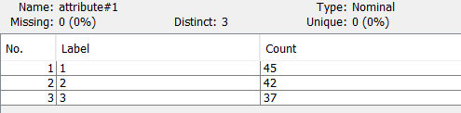1)Attribute 1: 1,2,3

2) Attribute 2: 1,2,3

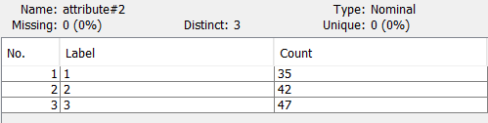

3) Attribute 3: 1,2

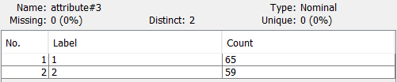

4) Attribute 4: 1,2,3

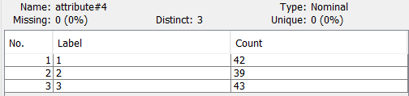

5) Attribute 5: 1,2,3,4

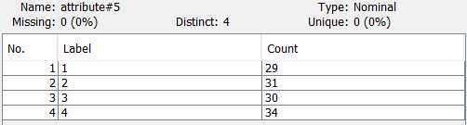

6) Attribute 6: 1,2

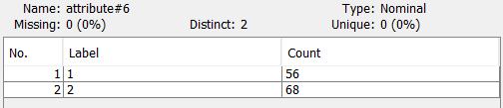

7)Class: 0, 1

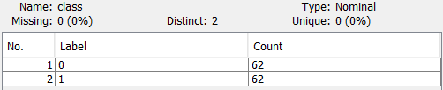

First, cluster the data with different algorithms and number of clusters. Use the Clusters to class evaluation model to see whether the clustering algorithm is able to discover the class division existing in the data.

## Simple k-means clustering(2 cluster)

As we can see below lustering using this method did not discover the class devision.

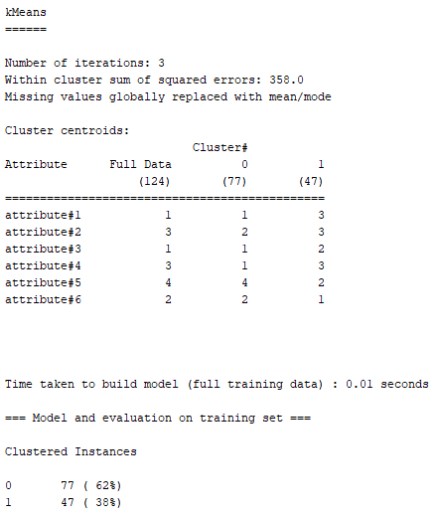

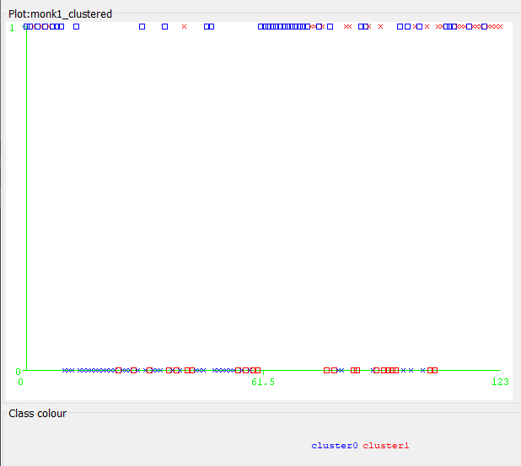

## Simple k-means clustering(3 cluster)

Increasing the number of clusters did not make any improvement.

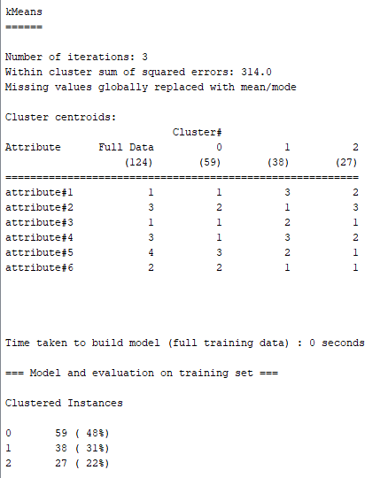

## EM algorithm(2 cluster)

As the plot below shows, this algorithm did not discover the classes as well. Changing the number of clusters did not make any improvement.

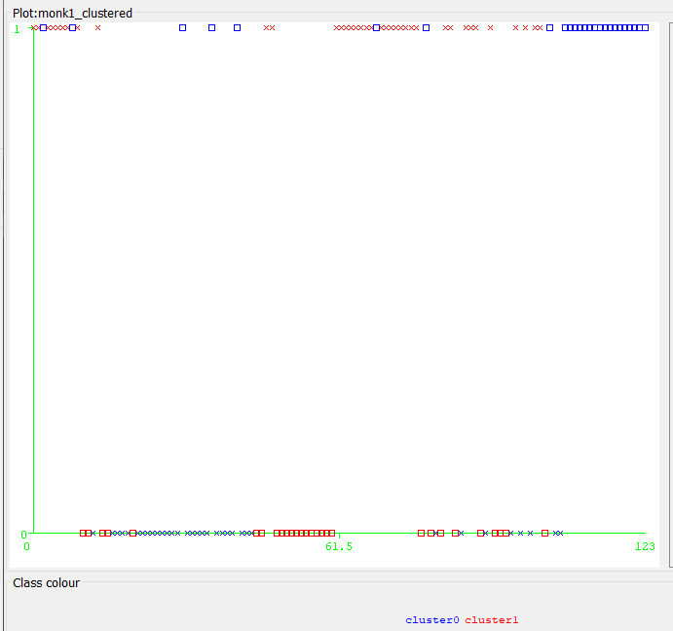

## MakeDensityBasedClusterer

This method also did not recognize the classes properly.

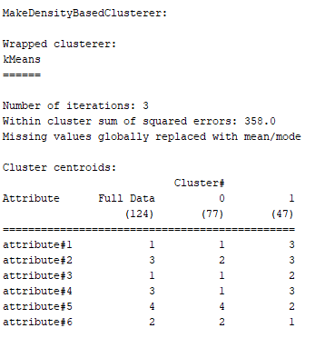

## Association Analysis

 minimum support of 0.05 and maximum number of rules of 19

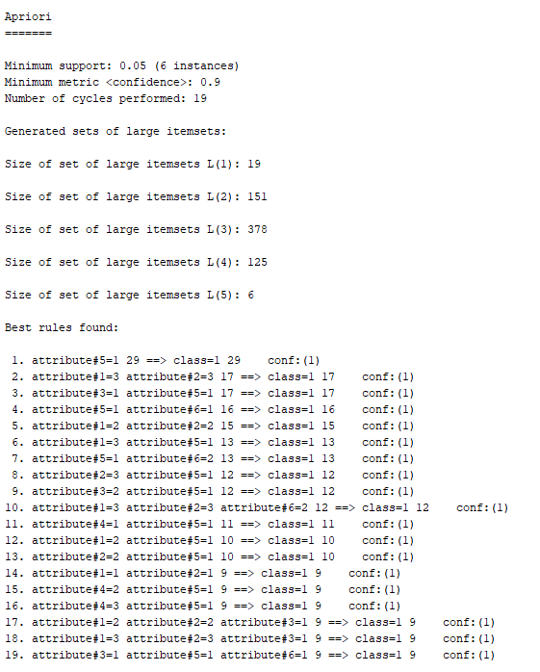

The first 4 rules seem to describe the class 1 properly. So we can use them to classify the points.

These attributes are categorical features. So a proper measure for distance should be employed in order to be clustered well. Clustering algorithm which we employed use numeric-based measurements. That is why they can not classify these dataset properly. On the other hand we can think of these attributes values as the transactional data, in which each sample is an itemset with different items which are the values of the attributes. Association analysis tries to find rules by analyzing these itemsets and it can properly find the rules which match some itemsets to class1